 | MINISTRY OF EDUCATION AND TRAINING

FPT UNIVERSITY
Capstone Project Document
FPT University Library Management System
Group 4
Group Members | QUANLM – Team Leader – 60209  PHUNH – Team Member – 60177  BAOTHQ – Team Member – 60006  DIEPTN – Team Member – 60128
Supervisor | TAINT
Ext Supervisor
Capstone Project code | LIB

- Ho Chi Minh City, 01/2012 -

Table of Contents
Report No.3: Software Requirements Specifications (SRS) 4
3.1. User Requirement Specification 4
3.2. System Requirement Specification (Specific Requirements) 4
3.2.1. External Interface Requirements 4
3.2.2. System Features 6
3.2.3. Software System Attributes 66
3.3. Entity Relationship Diagram or Data Structures 67
3.4. Other material (if any) 68

Table of Use-cases

Use Case 1: Search Catalogue 10
Use Case 2: View Detail Information of Catalogue 12
Use Case 3: Insert a Catalogue of Book 13
Use Case 4: Delete a Catalogue of Book 15
Use Case 5: Update Catalogue of Book 17
Use Case 6: Searching a Books & Copies 20
Use Case 7: View Information of Copies 21
Use Case 8: Insert Copies to a Catalogue 22
Use Case 9: Delete a number of Copies in Database 24
Use Case 10: Update Copies information 26
Use Case 11: View Category information 29
Use Case 12: Insert a new Category 30
Use Case 13: Delete a Category 32
Use Case 14: Edit a Category 34
Use Case 15: Register a Book online 37
Use Case 16: View Register information 39
Use Case 17: Confirm Registers 41
Use Case 18: Update after Reader take Copy of Book 43
Use Case 19: Borrow Copy of Book offline 45
Use Case 20: Return Copy of Book 47
Use Case 21: Expand a Borrow Time of a Copy 49
Use Case 22: Basic Search 51
Use Case 23: Detail Search 53
Use Case 24: Advanced Search 55
Use Case 25: Login 57
Use Case 26: View User Information 59
Use Case 27: Update User Information 61
Use Case 28: Delete an User 63
Use Case 29: Generate Report 65

Report No.3: Software Requirements Specifications (SRS)

User Requirement Specification

Overview

The system described in this document is one type of the library management system application. The features of the system consist of managing books, users, the transactions of borrowing and returning books… and the ability to generate required reports for the managers.

- Project Scope
The LIB system allows users to perform the following actions:
- Manage Catalogue (Titles and Copies): add, edit or remove one of the titles and copies in the system.
- Manage User Information: add, edit or remove users from the system.
- Manage Borrowing and Returning Transaction: approve and modify the transaction between users and library.
- Generate Reports: generate reports bases on the information from the library.

System Requirement Specification (Specific Requirements)

External Interface Requirements
    - User Interfaces
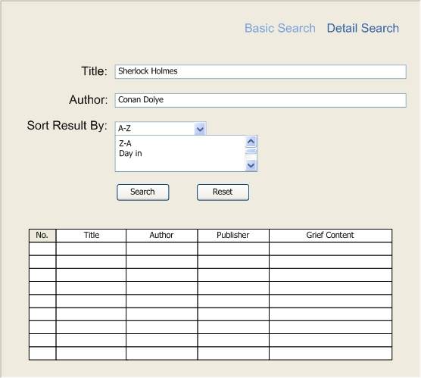
Figure 1: Sample of Basic Search feature

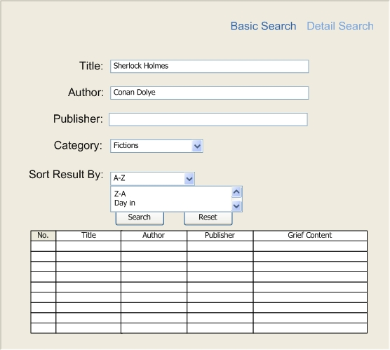
Figure 2: Sample of Detail Search feature

    - Hardware Interfaces
N/A
    - Software Interfaces
N/A
    - Communications Protocol
N/A

System Overview:
The System required users to login to be able to use some of the managing features. As of the administrator can be able to manage the users, the librarian can only manage the catalogue and normal user can only send request to the library.
The main features of the LIB can be described as the below diagram:
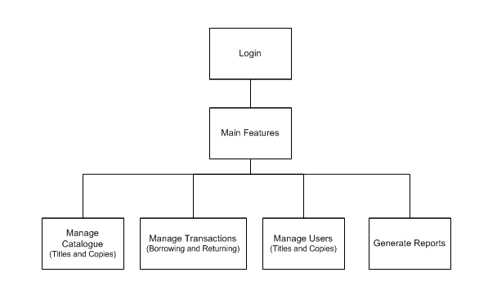
Figure 3: LIB System Overview

Type of the users in the LIB system:
- Admin: the Administrator of the system, admin has the primitive privilege on the system features and database. Only one admin is available in the system.
- Librarian: the Librarian of the Library, librarians can manage the titles and copies of the books in the library, the transaction between readers and library, but not the users’ information. Every business and document works must be performed by one of the librarians.
- Normal User: the Normal Reader of the system, login functionality is provided for the reader to order the copies of books only. Normal Reader cannot perform any managing activity.
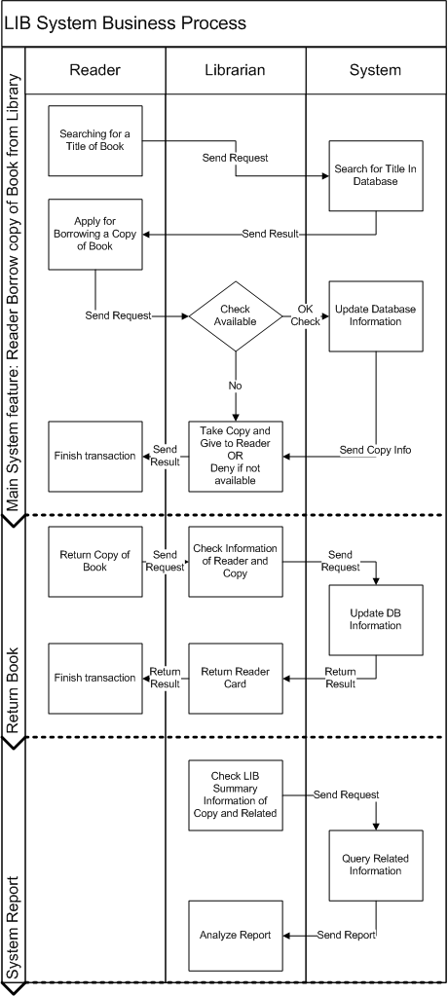
Figure 4: LIB System Business Functional Flowchart

System Features
- Manage Catalogue (Titles and Copies)
      - Use Case-A Diagram
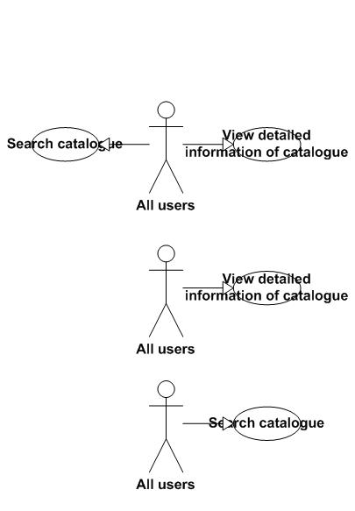
Figure 5: Searching & Viewing detailed Information
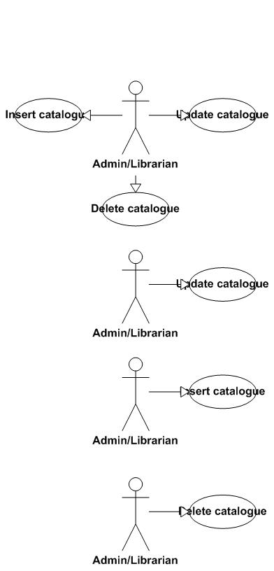
Figure 6: Catalogues management features
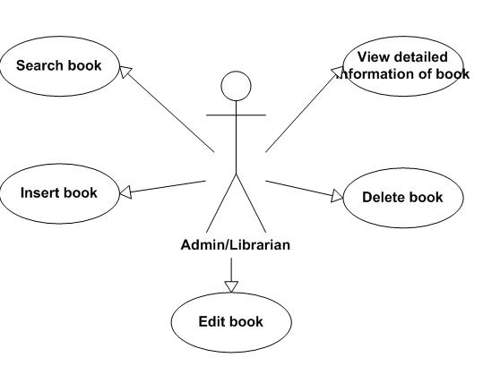
Figure 7: Copies management features
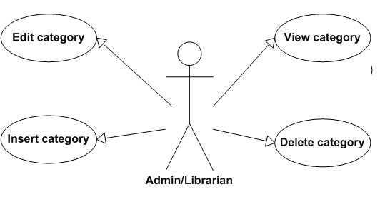
Figure 8: Categories management features
      - Use Case-A Specification

Use Case 1: Search Catalogue
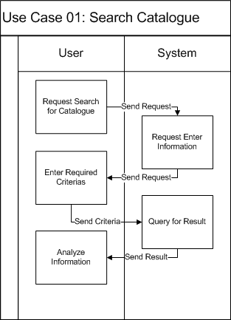

Use Case Name | Search catalogue of books
Actors | All users
Description | Search for some catalogues of books that are needed by users
Requirement | Fields/Attributes must have validations on it
Pre-conditions | Users must input keyword
Post-conditions | A list of result will be display
Basic Flow | Actor Actions:  1. Click “Search catalogue” button  3. User types keywords  4. Click "Search" button | System Response:  2. Display a search window form (in librarian management form) or a search page (in web form for readers)  5. A list of result will be displayed in users’ screens. If there is no result, will display “Sorry we can’t find the books you want.”
Exception Flow | N/A

Use Case 2: View Detail Information of Catalogue
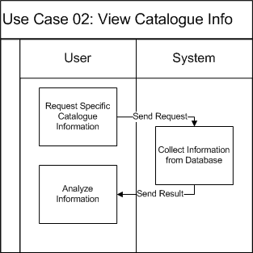

Use Case Name | View detailed information of the catalogue of books
Actors | All users
Description | View detailed information of the catalogue of books
Requirement | N/A
Pre-conditions | User choose the catalogue which they want to view detailed information
Post-conditions | Detailed information of catalogue will be displayed
Basic Flow | Actor Actions:  1. In the result form of search page. User clicks “View detailed information” button | System Response:  2. Display a new window form (in win form mode) or new web page (in web mode) that includes the detailed information of the catalogue.
Exception Flow | N/A

Use Case 3: Insert a Catalogue of Book
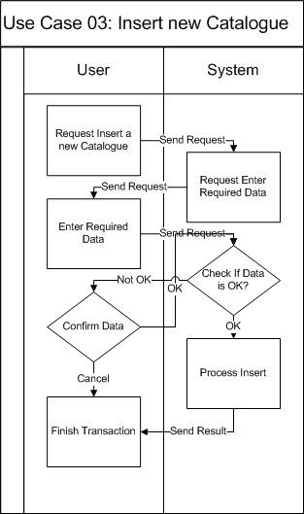
Use Case Name | Insert catalogue of books
Actors | Admin/Librarian
Description | Insert a catalogue of books to the database
Requirement | Fields/Attributes must have validations on it
Pre-conditions | User must log in with role “Admin” or “Librarian”
Post-conditions | New catalogue of books is added to database
Basic Flow | Actor Actions:  1. Click “Add catalogue” button  3. User types required attributes  4. Click "Insert" button  6. User click “Yes” button | System Response:  2. Display a form and request to enter the attributes that will be processed.  5. Message box confirms "Are you sure to insert this catalogue?“.  7. Data will be checked and insert to the database.
Alternative Flow 1 | Actor actions:  1. Click “No” button | System Response:  2. Stay in the current window form.
Exception Flow | N/A

Use Case 4: Delete a Catalogue of Book
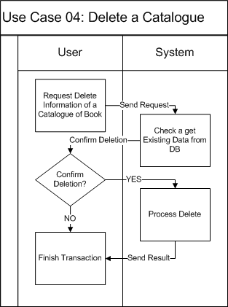
Use Case Name | Delete catalogue of books
Actors | Admin/Librarian
Description | Delete a catalogue of books to the database
Requirement | Fields/Attributes must have validations on it
Pre-conditions | User must log in with role “Admin” or “Librarian”
Post-conditions | The data of catalogue of books and all the books in the same catalogue will be deleted from the database
Basic Flow | Actor Actions:  1. In the result of search form or in the view detailed information form, user click “Delete” button.  6. User click “Yes” button | System Response:  2. Message box confirms "Are you sure to delete this catalogue and all the books belong to it? “.  7. The available book field in the database will set to 0 and all the books belong to it will be deleted from the database
Alternative Flow 1 | Actor actions:  1. Click “No” button | System Response:  2. Stay in the current window form.
Exception Flow | N/A

Use Case 5: Update Catalogue of Book
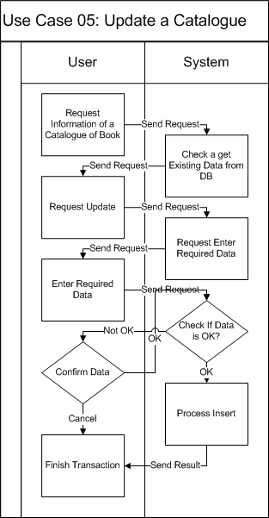
Use Case Name | Update catalogue of books
Actors | Admin/Librarian
Description | Update a catalogue of books to the database
Requirement | Fields/Attributes must have validations on it
Pre-conditions | User must log in with role “Admin” or “Librarian”
Post-conditions | New data of catalogue is modified to database
Basic Flow | Actor Actions:  1. In the result of search form or in the view detailed information form, user click “Edit” button.  3. User change the fields that they want to modify  4. Click "Edit" button  6. User click “Yes” button | System Response:  2. Display a form that has detailed information of catalogue and all the information appear in text box.  5. Message box confirms "Are you sure to change the information of this catalogue? “.  7. Data will be checked and updated to the database.
Alternative Flow 1 | Actor actions:  1. Click “No” button | System Response:  2. Stay in the current window form.
Exception Flow | N/A

Use Case 6: Searching a Books & Copies
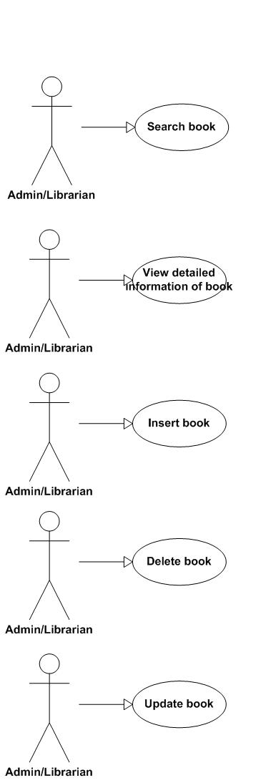
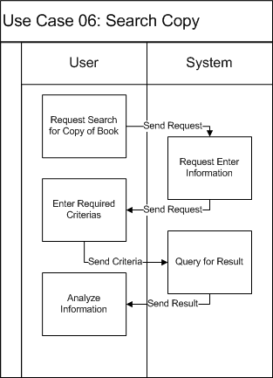
Use Case Name | Search book
Actors | Librarian/Admin
Description | Search for some catalogues of books that are needed by users
Requirement | Fields/Attributes must have validations on it
Pre-conditions | Users must input keyword
Post-conditions | A list of result will be display
Basic Flow | Actor Actions:  1. Click “Search book” button  3. User types keywords  4. Click "Search" button | System Response:  2. Display a search window form  5. A list of result will be displayed in users’ screens. If there is no result, will display “Sorry we can’t find the book you want.”
Exception Flow | N/A

Use Case 7: View Information of Copies
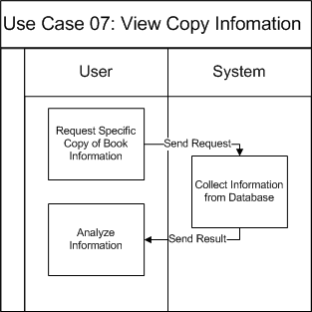
Use Case Name | View detailed information of book
Actors | All users
Description | View detailed information of the book
Requirement | N/A
Pre-conditions | User choose the book which they want to view detailed information
Post-conditions | Detailed information of book will be displayed
Basic Flow | Actor Actions:  1. In the result form of search page. User clicks “View detailed information” button | System Response:  2. Display a new window form that includes the detailed information of the book.
Exception Flow | N/A

Use Case 8: Insert Copies to a Catalogue
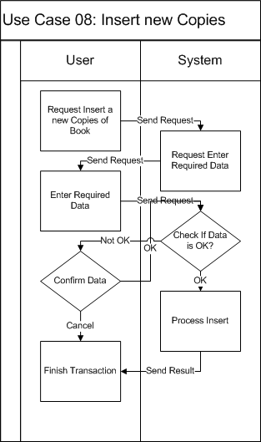
Use Case Name | Insert book
Actors | Admin/Librarian
Description | Insert books to the database
Requirement | Fields/Attributes must have validations on it
Pre-conditions | User must log in with role “Admin” or “Librarian”
Post-conditions | New books is added to database
Basic Flow | Actor Actions:  1. In the detailed catalogue information page, user click “Add book” button  3. User types required attributes or choose the number of books  4. Click "Insert" button  6. User click “Yes” button | System Response:  2. Display a form and request to enter the attributes that will be processed (with separate book) or the number of books that they want to add to the catalogue.  5. Message box confirms "Are you sure to insert book? “.  7. Data will be checked and insert to the database.
Alternative Flow 1 | Actor actions:  1. Click “No” button | System Response:  2. Stay in the current window form.
Exception Flow | N/A

Use Case 9: Delete a number of Copies in Database
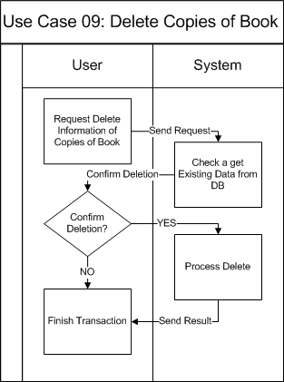
Use Case Name | Delete book
Actors | Admin/Librarian
Description | Delete a book from the database
Requirement | Fields/Attributes must have validations on it
Pre-conditions | User must log in with role “Admin” or “Librarian”
Post-conditions | book will be deleted from the database
Basic Flow | Actor Actions:  1. In the result of search form or in the view detailed information form, user click “Delete” button.  6. User click “Yes” button | System Response:  2. Message box confirms "Are you sure to delete this book? “.  7. The selected book will be deleted from the database
Alternative Flow 1 | Actor actions:  1. Click “No” button | System Response:  2. Stay in the current window form.
Exception Flow | N/A

Use Case 10: Update Copies information
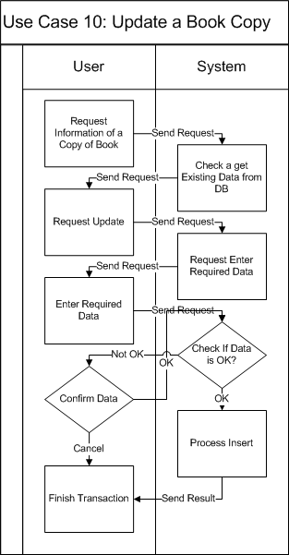
Use Case Name | Update a book
Actors | Admin/Librarian
Description | Update an information of a book to the database
Requirement | Fields/Attributes must have validations on it
Pre-conditions | User must log in with role “Admin” or “Librarian”
Post-conditions | New data of book is modified to database
Basic Flow | Actor Actions:  1. In the result of search form or in the view detailed information form, user click “Edit” button.  3. User change the fields that they want to modify  4. Click "Edit" button  6. User click “Yes” button | System Response:  2. Display a form that has detailed information of book and all the information which user can modify is appeared in text box.  5. Message box confirms "Are you sure to change the information of this catalogue?”.  7. Data will be checked and updated to the database.
Alternative Flow 1 | Actor actions:  1. Click “No” button | System Response:  2. Stay in the current window form.
Exception Flow | N/A

Use Case 11: View Category information
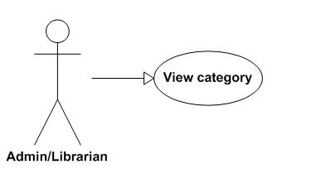
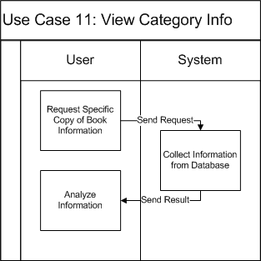
Use Case Name | View category
Actors | Admin/Librarian
Description | View detailed information of category
Requirement | N/A
Pre-conditions | User choose the category which they want to view detailed information
Post-conditions | Detailed information of category will be displayed
Basic Flow | Actor Actions:  1. In the result form of search page. User clicks “View detailed information” button | System Response:  2. Display a new window form that includes the detailed information of the category.
Exception Flow | N/A

Use Case 12: Insert a new Category
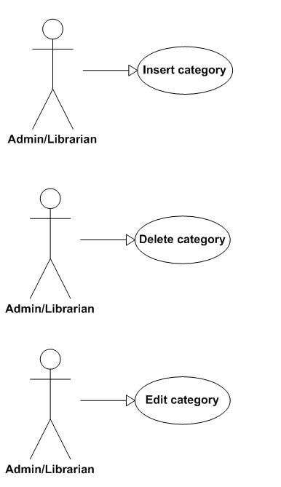
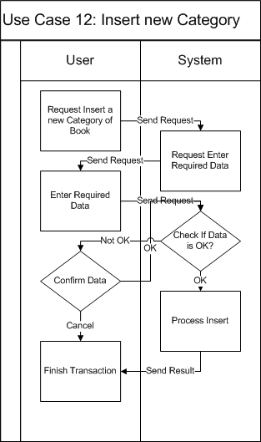
Use Case Name | Insert category of books
Actors | Admin/Librarian
Description | Insert a category of books to the database
Requirement | Fields/Attributes must have validations on it
Pre-conditions | User must log in with role “Admin” or “Librarian”
Post-conditions | New category of books is added to database
Basic Flow | Actor Actions:  1. Click “Add category” button  3. User types required attributes  4. Click "Insert" button  6. User click “Yes” button | System Response:  2. Display a form and request to enter the attributes that will be processed.  5. Message box confirms "Are you sure to insert this category? “.  7. Data will be checked and insert to the database.
Alternative Flow 1 | Actor actions:  1. Click “No” button | System Response:  2. Stay in the current window form.
Exception Flow | N/A

Use Case 13: Delete a Category
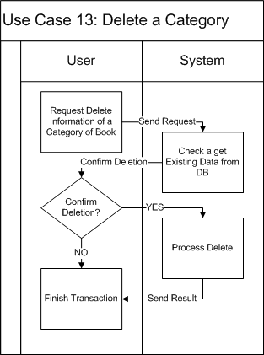
Use Case Name | Delete category of books
Actors | Admin/Librarian
Description | Delete a category of books from the database
Requirement | Fields/Attributes must have validations on it
Pre-conditions | User must log in with role “Admin” or “Librarian”
Post-conditions | The category will be delete from the database and all the catalogue that referenced to this category will be referenced to the parent category or set to uncategorized
Basic Flow | Actor Actions:  1. In the result of search form or in the view detailed information form, user click “Delete” button.  3. User click “Yes” button | System Response:  2. Message box confirms "Are you sure to delete this category? “.  7. The category will be delete from the database and all the catalogue that referenced to this category will be referenced to the parent category or set to uncategorized
Alternative Flow 1 | Actor actions:  1. Click “No” button | System Response:  2. Stay in the current window form.
Exception Flow | N/A

Use Case 14: Edit a Category
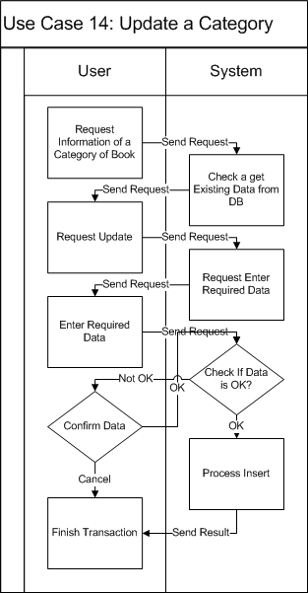
Use Case Name | Update category of books
Actors | Admin/Librarian
Description | Update a category of books to the database
Requirement | Fields/Attributes must have validations on it
Pre-conditions | User must log in with role “Admin” or “Librarian”
Post-conditions | New data of category is modified to database
Basic Flow | Actor Actions:  1. In the result of search form or in the view detailed information form, user click “Edit” button.  3. User change the fields that they want to modify  4. Click "Edit" button  6. User click “Yes” button | System Response:  2. Display a form that has detailed information of category and all the information appear in text box.  5. Message box confirms "Are you sure to change the information of this category? “.  7. Data will be checked and updated to the database.
Alternative Flow 1 | Actor actions:  1. Click “No” button | System Response:  2. Stay in the current window form.
Exception Flow | N/A

- Manage Transactions (Borrowing and Returning)
- Use Case-B Diagram
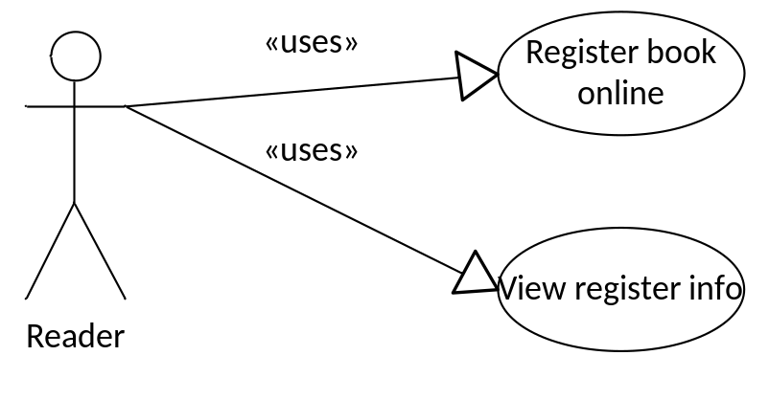
Figure 9: Reader’s related features
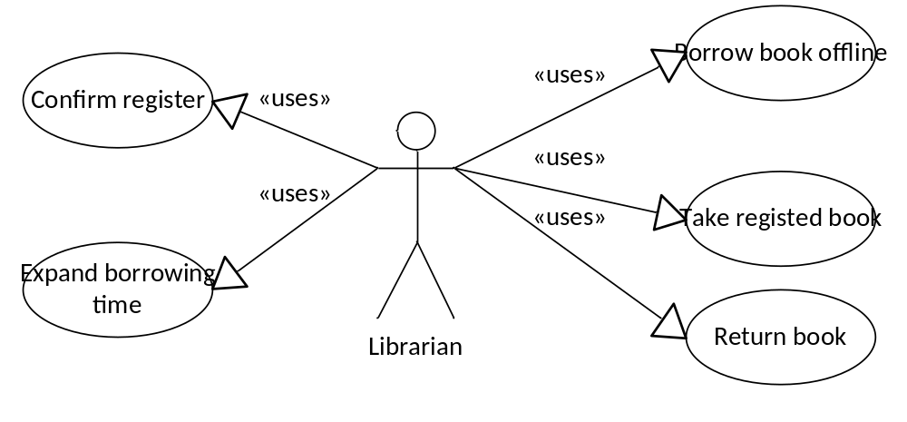
Figure 10: Internal User’s related features
- Use Case-B Specification

Use Case 15: Register a Book online
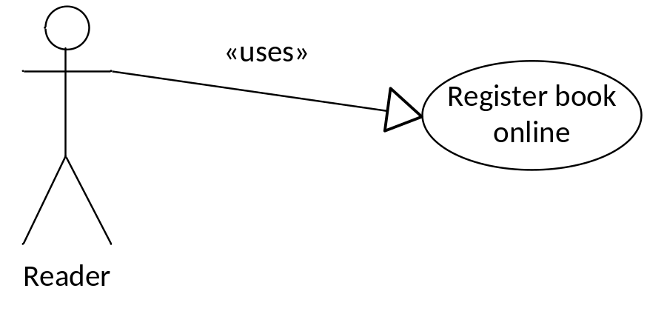
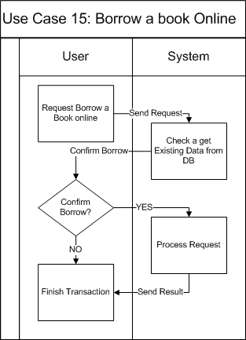
Use Case Name | Register book online
Actors | Reader
Description | Register book online
Requirement | User is available to borrow book
Pre-conditions | User must log in as a reader
Post-conditions | New register record is inserted into database
Basic Flow | Actor Actions:  1. Click Register icon on a book  4. Click OK  [Alternative Flow 1] | System Response:  3. Display confirm message  5. Save register info to database.  6. Display info message  7. Back to book list page
Alternative Flow 1 | Actor actions:  1. Click “Cancel” | System Response:  2. Back to book list page
Exception Flow | N/A

Use Case 16: View Register information
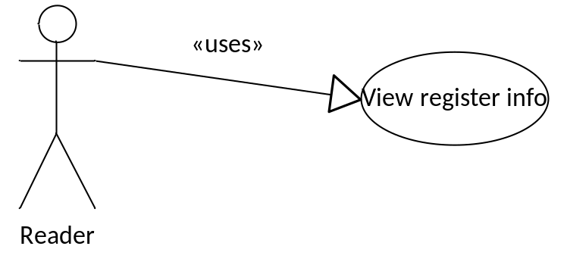
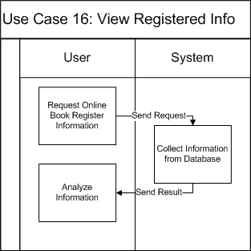
Use Case Name | View register info
Actors | Reader
Description | View register info
Requirement | N/A
Pre-conditions | User must log in as a reader
Post-conditions | Register info is displayed
Basic Flow | Actor Actions:  1. Click “View Register Info” | System Response:  2. Display all register of the logged in user
Exception Flow | N/A

Use Case 17: Confirm Registers
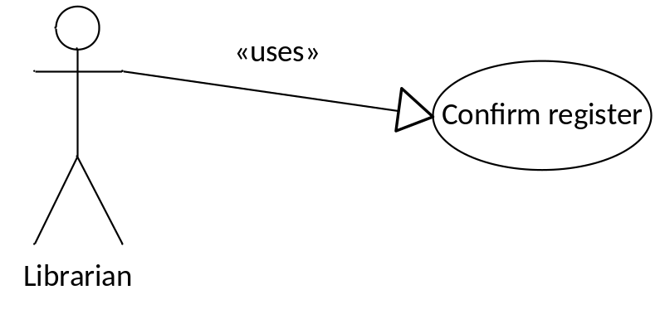
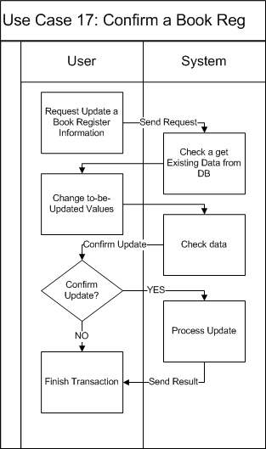
Use Case Name | Confirm register
Actors | Librarian
Description | Confirm register
Requirement | N/A
Pre-conditions | User must log in as a librarian
Post-conditions | New borrowing record is inserted into database
Basic Flow | Actor Actions:  1. Click “View Register”  3. Select a register  4. Click “Confirm”  [Alternative Flow 1]  6. Click “OK”  [Alternative Flow 2] | System Response:  2. Display all available registers  5. Display confirm message box  7. Update register info  8. Back to register list page
Alternative Flow 1 | Actor actions:  1. Click “Deny”  3. Click “OK”  [Alternative Flow 2] | System Response:  2. Display confirm message box  4. Update register info  5. Back to register list page
Alternative Flow 2 | Actor actions:  1. Click “Cancel” | System Response:  2. Back to register list page
Exception Flow | N/A

Use Case 18: Update after Reader take Copy of Book
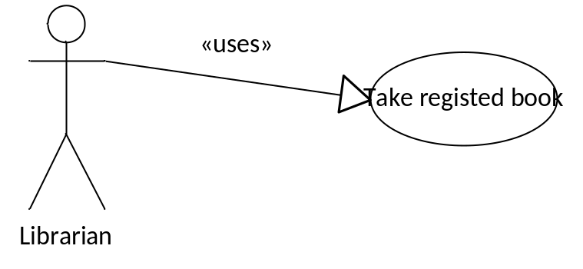
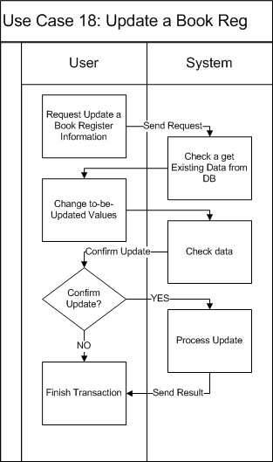
Use Case Name | Take registered book
Actors | Librarian
Description | Reader takes registered book
Requirement | Reader info is available
Pre-conditions | User must log in as a librarian
Post-conditions | New borrowing record is inserted into database  Register record is updated
Basic Flow | Actor Actions:  1. User input Reader ID  3. Click “Take Book” button  5. Select the required book  6. Click “Take”  8. Click “OK”  [Alternative Flow 1] | System Response:  2. Display reader info  4. Display a list of registered book  7. Display confirm message  9. Save borrowing info to database  10. Update register info  11. Display info message
Alternative Flow 1 | Actor actions:  1. Click “Cancel” | System Response:  2. Back to list book page
Exception Flow | N/A

Use Case 19: Borrow Copy of Book offline
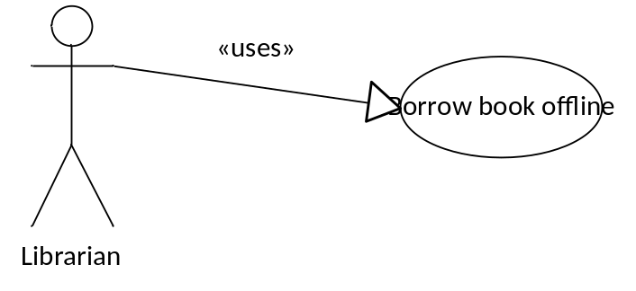
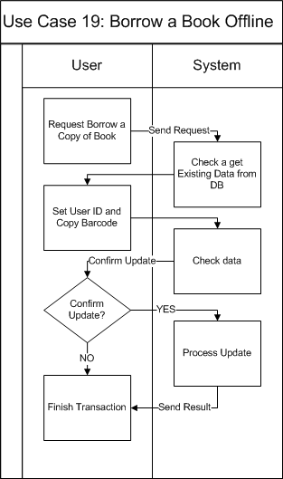
Use Case Name | Borrow book offline
Actors | Librarian
Description | Borrow book offline
Requirement | Reader info is available
Pre-conditions | User must log in as a librarian
Post-conditions | New borrowing record is inserted into database
Basic Flow | Actor Actions:  1. User input Reader ID  3. Click “Borrow Book” button  5. Select the required book  6. Click “Borrow”  8. Click “OK”  [Alternative Flow 1] | System Response:  2. Display reader info  4. Display list book page  7. Display confirm message  9. Save borrowing info to database  10. Display info message
Alternative Flow 1 | Actor actions:  1. Click “Cancel” | System Response:  2. Return to list book page
Exception Flow | N/A

Use Case 20: Return Copy of Book
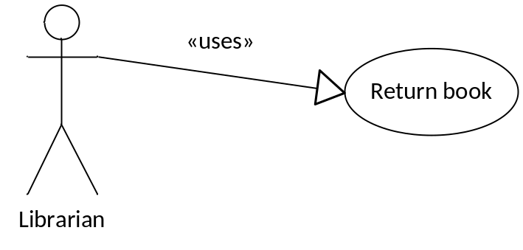
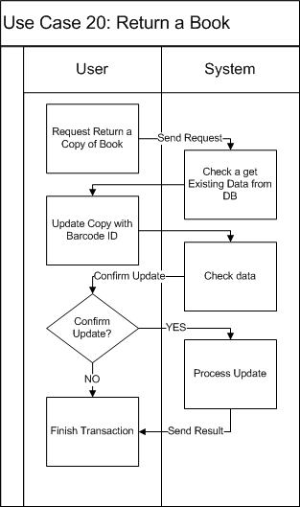
Use Case Name | Return book
Actors | Reader
Description | Reader returns book
Requirement | Reader info is available
Pre-conditions | User must log in as a librarian
Post-conditions | Borrowing record is updated
Basic Flow | Actor Actions:  1. User input Reader ID  3. Click “Return Book” button  5. Select the required book  6. Click “Return”  8. Click “OK”  [Alternative Flow 1] | System Response:  2. Display reader info  4. Display list of currently borrowed books  7. Display confirm message  9. Save borrowing info to database
Alternative Flow 1 | Actor actions:  1. Click “Cancel” | System Response:  2. Return to list book page
Exception Flow | N/A

Use Case 21: Expand a Borrow Time of a Copy
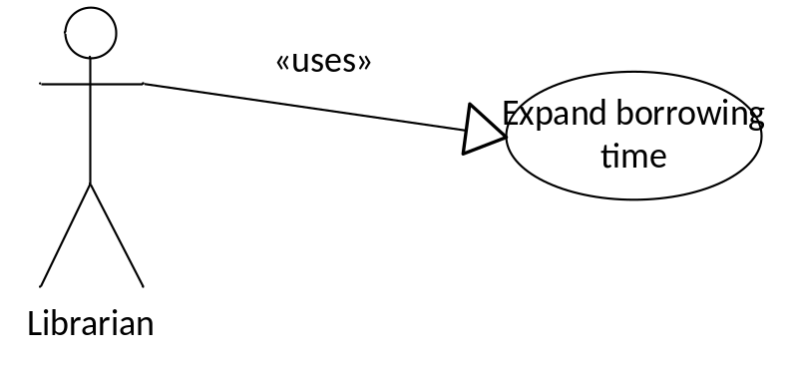
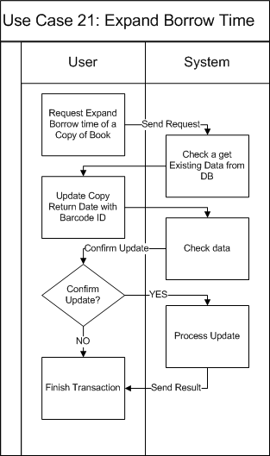
Use Case Name | Expand borrowing time
Actors | Librarian
Description | Expand borrowing time
Requirement | Reader info is available
Pre-conditions | User must log in as a librarian
Post-conditions | Borrowing record is updated
Basic Flow | Actor Actions:  1. User input Reader ID  2. Click “Expand time”  3. Select a borrowing record  5. Choose a date to expand to  6. Click “OK”  [Alternative Flow 1] | System Response:  3. Display list of borrowing records  4. Display a form and let user modify its info  Form includes:  - Date to expand to  7. Save borrowing info to database  8. Display info message
Alternative Flow 1 | Actor actions:  1. Click “Cancel” | System Response:  2. Return to borrowing records list
Exception Flow | N/A

- Searching features of the system.
- Use Case-C Diagram
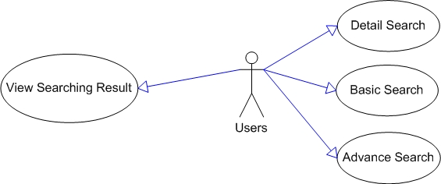
Figure 11: Searching features of the LIB System
- Use Case-C Specification

Use Case 22: Basic Search
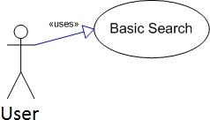
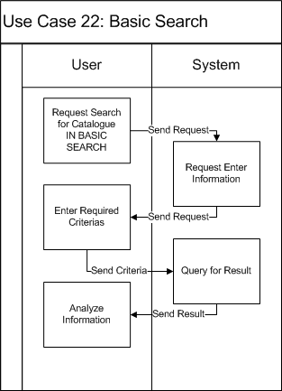

Use Case Name | Book Basic Search Use Case
Actors | Librarian/Admin/Normal users
Description
Requirement | For authorized users only
Pre-conditions | User must log in the system
Post-conditions
Basic Flow | Actor Actions:  1. Click “Search for books” (button)  3. User types required attributes  4. Click "Search" button  [Alternative Flow 1] | System Response:  2. Display a form and request to enter the attributes that will be processed.  Form includes:  - Title: String, Textbox (Required)  - Author: String, Textbox (Required)  - Publisher: String. Textbox (Required)  5. Data will be checked then show searching result
Alternative Flow 1 | Actor actions:  1. Click “Reset” button  3. Click "Yes"  [Alternative Flow 2] | System Response:  2. Message box confirms "Do you want to reset your searching data?"  4. Erase data in textboxes
Alternative Flow 2 | Actor Actions:  1. Click "No" button | System Response:  2. Stay at current state.
Exception Flow | N/A

Use Case 23: Detail Search
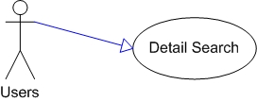
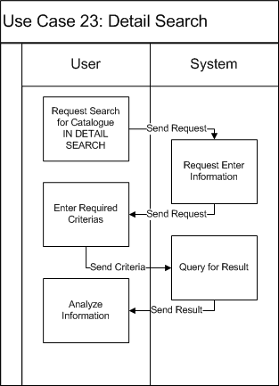
Use Case Name | Book Detail Search Use Case
Actors | Librarian/Admin/Normal users
Description
Requirement | For authorized users only
Pre-conditions | User must log in the system
Post-conditions
Basic Flow | Actor Actions:  1. Click “Search for books” (button)  3. User types required attributes  4. Click "Search" button  [Alternative Flow 1] | System Response:  2. Display a form and request to enter the attributes that will be processed.  Form includes:  - Title: String, Textbox (Required)  - Author: String, Textbox (Required)  - Publisher: String. Textbox (Required)  5. Data will be checked then show searching result
Alternative Flow 1 | Actor actions:  1. Click “Reset” button  3. Click "Yes"  [Alternative Flow 2] | System Response:  2. Message box confirms "Do you want to reset your searching data?"  4. Erase data in textboxes
Exception Flow | N/A

Use Case 24: Advanced Search
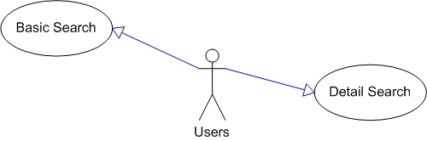
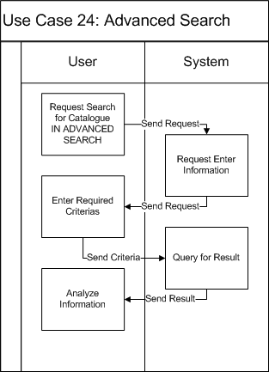
Use Case Name | Book Advance Search Use Case
Actors | Librarian/Admin/Normal users
Description
Requirement | For authorized users only
Pre-conditions | User must log in the system
Post-conditions
Basic Flow | Actor Actions:  1. Click “Search for books” (button)  3. User types required attributes  4. Click "Search" button  [Alternative Flow 1] | System Response:  2. Display a form and request to enter the attributes that will be processed.  Form includes:  - Title: String, Textbox (Required)  - Author: String, Textbox (Required)  - Publisher: String. Textbox (Required)  5. Data will be checked then show searching result
Alternative Flow 1 | Actor actions:  1. Click “Reset” button  3. Click "Yes"  [Alternative Flow 2] | System Response:  2. Message box confirms "Do you want to reset your searching data?"  4. Erase data in textboxes
Exception Flow | N/A

- Manage Users’ Information
- Use Case-D Diagram
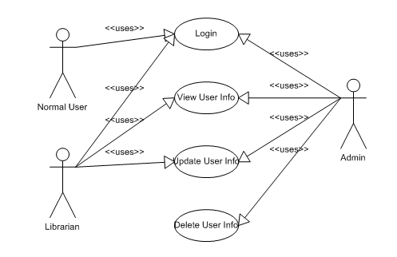
Figure 12: User Management features
- Use Case-D Specification

Use Case 25: Login
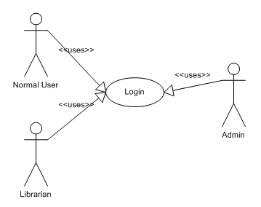
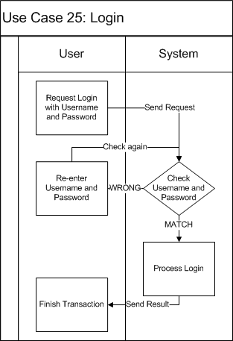

Use Case Name | Login Use Case
Actors | Admin/Librarian/Normal User
Description | Log a user into LIB System
Requirement | N/A
Pre-conditions | N/A
Post-conditions | User will be logged into LIB System. New working session will be created
Basic Flow | Actor Actions:  1. In the Login form of the Win-form application or the Login page of the OOPAC, user will have to enter the username and password and then click “Login” button. | System Response:  2. The system will check the username and password from user and if the user name password are right. [Alternative Flow 2]  Else [Alternative Flow 1]
Alternative Flow 1 | Actor Actions:  2. The User will enter again username and password | System Response:  1. The system alert user about “wrong username or password and request enter again.”  3. Check username and password, if username and password are right. [Alternative Flow 2]  Else [Alternative Flow 1]
Alternative Flow 1 | Actor Actions: | System Response:  1. Log the user into the system and create a new working session.
Exception Flow | N/A

Use Case 26: View User Information
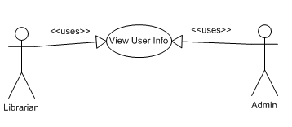
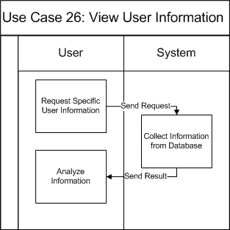

Use Case Name | View User Information Use Case
Actors | Admin/Librarian
Description | View an User Information
Requirement | N/A
Pre-conditions | User must log in with role “Admin”/“Librarian”
Post-conditions | Detail information of selected user will be shown
Basic Flow | Actor Actions:  1. In the user list view, the librarian or admin click on one user to view the detailed information of that user. | System Response:  2. The detailed Information of that user will be shown in a User Detail Form.
Exception Flow | N/A

Use Case 27: Update User Information
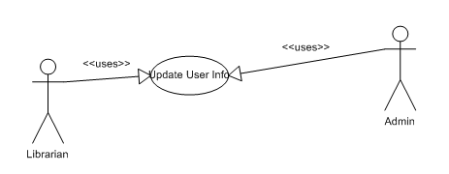
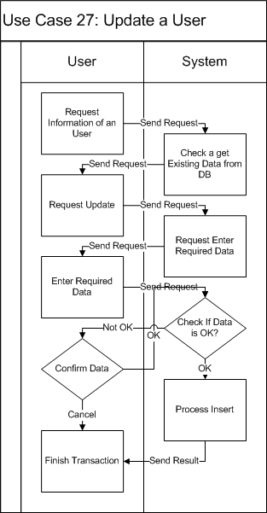
Use Case Name | Update User Information Use Case
Actors | Admin/Librarian
Description | Update an User Information
Requirement | Fields/Attributes must have validations on it
Pre-conditions | User must log in with role “Admin”/“Librarian”
Post-conditions | Detail information of selected user will be updated
Basic Flow | Actor Actions:  1. In the user Detail Information, the librarian or admin edit the detailed information of that user.  2. Click on “Save” button.  4. Click on “Yes”.  6. Click on “No”  [Alternative Flow 1] | System Response:  3. Show message “Are you sure want to update this user information?”  5. The detailed Information of that user will be updated in the DB.
Alternative Flow 1 | Actor Actions:  1. User click on “No” button of confirm message. | System Response:  2. The user information remains unchanged.
Exception Flow | N/A

Use Case 28: Delete an User
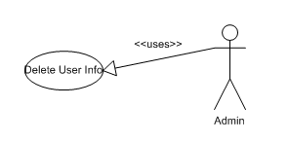
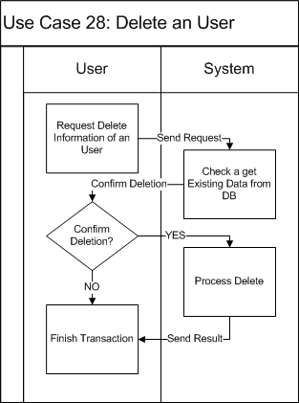
Use Case Name | Delete User Information Use Case
Actors | Admin
Description | Delete an User Information
Requirement | Fields/Attributes must have validations on it
Pre-conditions | User must log in with role “Admin”
Post-conditions | Detail information of selected user will be deleted
Basic Flow | Actor Actions:  1. In the user Detail Information, the librarian or admin click on “Delete” button.  4. Click on “Yes”.  6. Click on “No”  [Alternative Flow 1] | System Response:  3. Show message “Are you sure want to delete this user?”  5. The detailed Information of that user will be deleted in the DB.
Alternative Flow 1 | Actor Actions:  1. User click on “No” button of confirm message. | System Response:  2. The user information remains unchanged.
Exception Flow | N/A

- Generate Reports
- Use Case-E Diagram
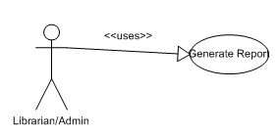
Figure 13: Generate Report
- Use Case-E Specification

Use Case 29: Generate Report
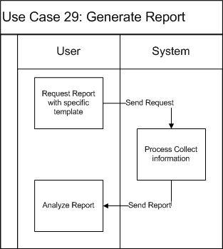

Use Case Name | Generate Report Use Case
Actors | Admin/Librarian
Description | Generate Report based on the report template.
Requirement | N/A
Pre-conditions | User must log in with role “Admin”/“Librarian”
Post-conditions | The Report will be generated and shown.
Basic Flow | Actor Actions:  1. In the Report Menu, User will have to choose the type of report to be generated and click Create Report. | System Response:  2. LIB will send request to DB system to collect information then create and show the report.
Exception Flow | N/A

Software System Attributes
- Reliability
- The system can be used like “always on” system.
- There is no requirement for system maintenance task from the user.
- Mean Time Between Failures (MTBF): more than 6 months.
- Mean Time To Repair (MTTR): less than 72 hours.
- Accuracy: 100%
- Maximum Bugs and Defect Rate: 0.3 bugs per thousand lines of code (0.3 bugs/KLOC).
- Critical bugs:
- Loss of data: not any
- Unable to use part of the system’s functionality: not any

- Availability
It should be available as a minimum 99.99% when any one of these subsystems is available.

- Security: there are 3 types of the users in the LIB System
- Admin: the Administrator of the system, admin has the primitive privilege on the system features and database. Only one admin is available in the system.
- Librarian: the Librarian of the Library, librarians can manage the titles and copies of the books in the library, the transaction between readers and library, but not the users’ information. Every business and document works must be performed by one of the librarians.
- Normal User: the Normal Reader of the system, login functionality is provided for the reader to order the copies of books only. Normal Reader cannot perform any managing activity.

- Maintainability
The LIB should have the ability to auto-update without hiatus the system.

- Portability
The LIB shall enable users to use the following environments (e.g., platform and operating system) to interact with the LIB:
- User Personal Computer:
  - PC with minimum of Pentium IV chip, 512MB of RAM, and a 56 K modem
  - Dot NET Environment
- Operating System:
  - Microsoft Windows XP or above
  - Mac OS X 10.0 or above
  - Linux 3.5 or above
- Connection:
  - 56 kbps or other type of connection.

- Performance
- Response time for a search:
  - Average: 100 millisecond/search
  - Maximum: 250 millisecond/search
- Maximum number of concurrent users:
  - 1000 concurrent users
- Disk:
  - Database: depends on the number of publication records.
  - Hard drive space to install application on each computer: 150 megabytes.

Entity Relationship Diagram or Data Structures
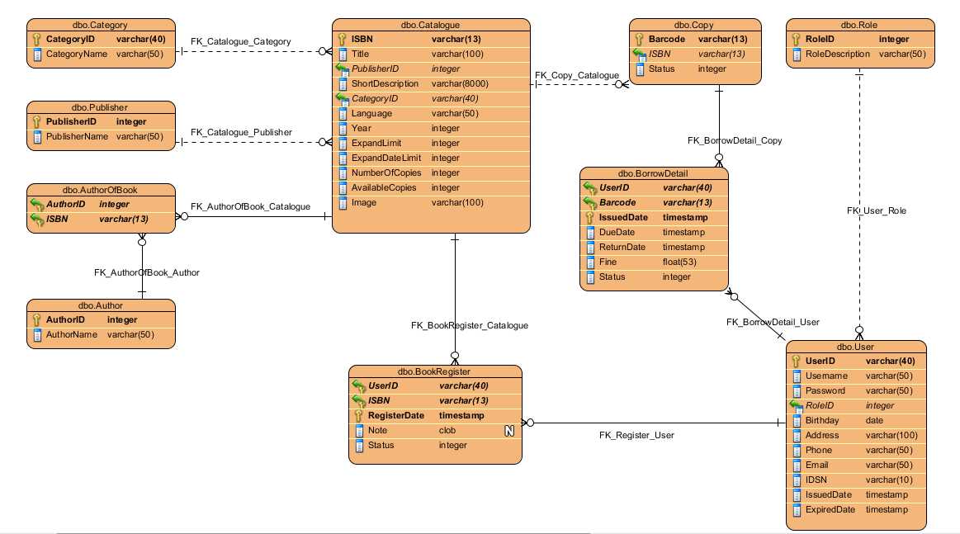

Other material (if any)
N/A

